NAMC MAP IT Quick Start Guide
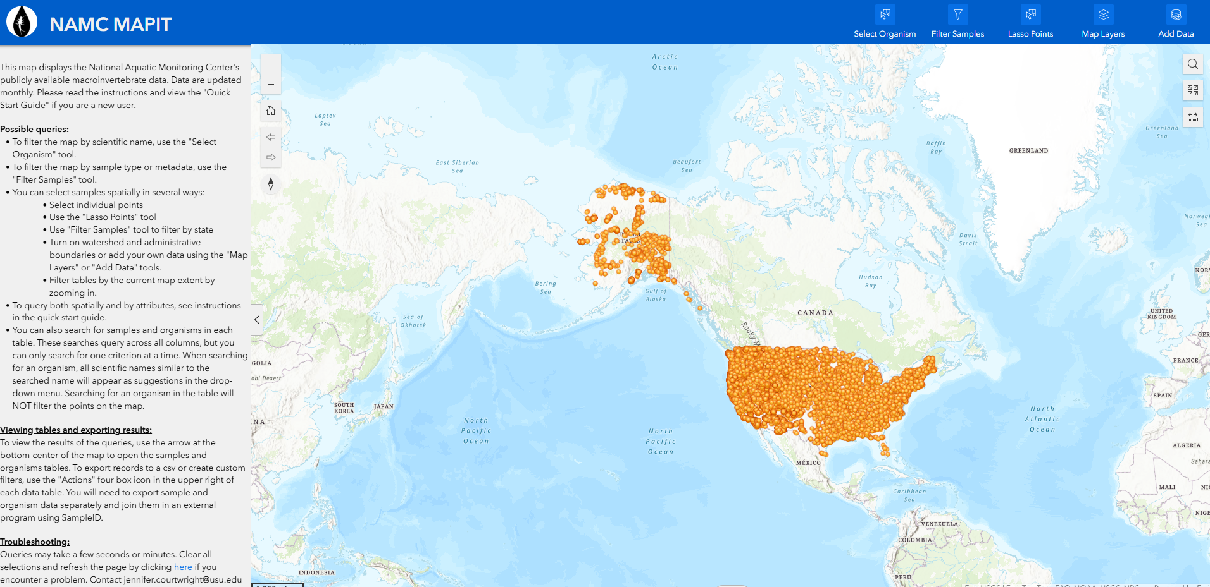
Table of Contents
Select Organism 2
Filter Samples 3
Lasso Points 4
Add watershed or administrative boundaries 5
Add other data 5
Search within tables 6
Select records within tables 6
Export data for each table 7
Querying both spatially and by attributes 7
Troubleshooting 8

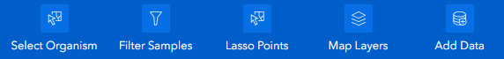

Find the distribution of a specific species

Step 1. Filter the map to only samples with a given organism by clicking the highlighted buttons.
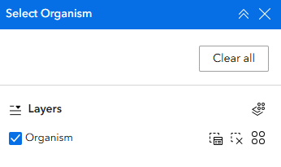
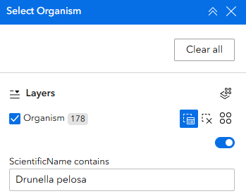

Step 2. Open organisms table to view selected taxa
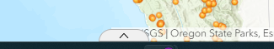

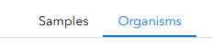

Filter the map by state or sample information

Step 1. Type in criteria and hit enter or select multiple options from the drop-down lists. Clear selections by using the refresh button in the lower right.
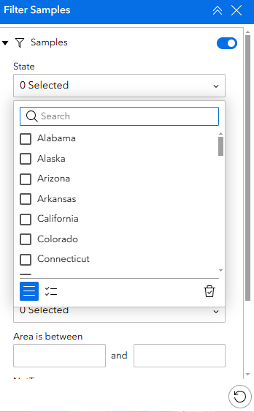
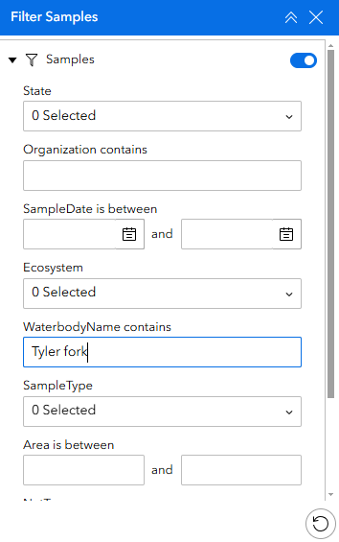

Step 2. Open samples table to view selected samples. To view

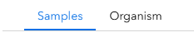

Select samples spatially using a lasso

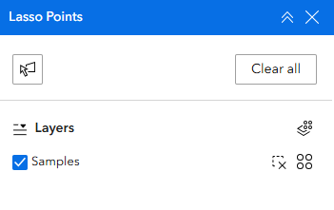
Step 1. Turn on lasso by clicking the highlighted button

Step 2. Click to create vertices or click and drag your mouse. Double click to complete lasso.
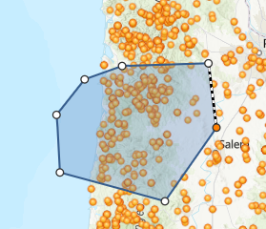

Step 3. Open samples table to view selected samples

Add watershed or administrative boundaries

Watershed boundaries or USFS, BLM, or NPS boundaries can be added easily to the map by turning these layers on. The zoom level of the map controls what layers are available to turn on
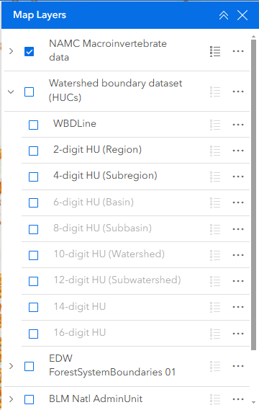

Add other data as desired

Search within tables
You can also search for samples and organisms in each table. These searches query across all columns, but you can only search for one criterion at a time. When searching for an organism, all scientific names similar to the searched name will appear as suggestions in the drop-down menu. Searching for an organism in the table will NOT filter the points on the map.

Select records within tables
Zooming in to a specific location will filter the samples table to the current map extent. Selecting a sample in the table will filter the map to that sample. It will also filter the organisms table to only that sample. Likewise, selecting an organism in the organism table will filter the samples table to only that sample.
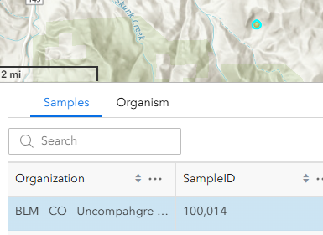
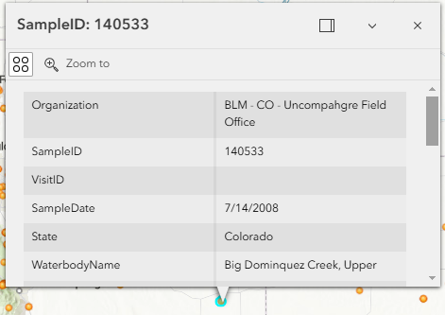
Selecting a point on the map will also select the sample in the table. View the selected records by clicking the view selected records button on the right side of the table.
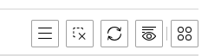
View selected records
Clear selected records

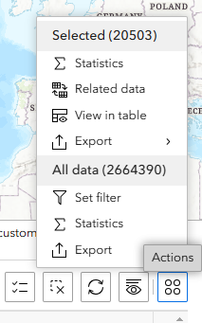
Open menu
Export selected records
Export all records

Export data for each table

Note that exporting selected records in the organisms table will only export a maximum of 2000 records. To export ALL selected records, ensure that the organisms table is filtered to only selected records and then use the export ALL option.

Querying across organisms, sample information, and location
Queries are only additive if samples are selected rather than filtered. See additional directions below depending on your query type.
Query by organisms and location
- Use the “Select Organism” tool to select a specific organism.
- Use the “Lasso Points” tool to select an area of interest.
- Then follow directions above to export ALL selected organisms.
Query all organisms for a state, agency, or sample type
- Use the “Filter Samples” tool to filter samples to a state, agency or other criteria.
- Use the “Lasso Points” tool to select all filtered samples on the map.
- Then follow directions above to export ALL selected organisms.
Query by sample type and organism
- Use the “Filter Samples” tool to filter samples to a state, agency or other criteria.
- Use the “Lasso Points” tool to select all filtered samples on the map.
- Search for an organism within those selected points.
- Then follow directions above to export ALL selected organisms.

Troubleshooting
If you select more than 4000 samples the page will freeze. Please divide up larger queries or contact Jennifer.courtwright@usu.edu for a custom export.
Clear all selections and refresh the page by clicking here if you encounter a problem. Contact jennifer.courtwright@usu.edu with questions.﻿

