Introduction
The objective of the Aquatic and Riparian Effectiveness Monitoring Program (AREMP) is to determine the efficacy of the Northwest Forest Plan’s Aquatic Conservation Strategy to maintain and restore watershed condition. Watersheds in “good” condition are defined as those having the processes necessary to create and maintain habitat conditions for fish and other aquatic and riparian-dependent species (Reeves et al. 2003). Watershed condition is evaluated in terms of inchannel (e.g., substrate, large woody debris, water temperature, macroinvertebrates), riparian and upslope (e.g., roads, vegetation) conditions. To be effective, AREMP needs to be able to track the condition and trend of priority attributes at both regional and local scales.
The overall goal of this effort was to develop a bioassessment tool, using aquatic macroinvertebrates, to quantify the condition and trend of both biological integrity and inchannel habitat conditions. Similar to other large-scale aquatic monitoring efforts, AREMP has invested heavily in the use of macroinvertebrates as their primary indicator of inchannel biological integrity; over the course of twelve years, AREMP has collected more than 1,700 benthic macroinvertebrate samples. To effectively use macroinvertebrates as a monitoring tool, AREMP sought an analytical framework for making accurate and precise biological condition determinations at both local and regional scales.
We developed two bioassessment indices for AREMP: an observed to expected (O/E) index of taxonomic completeness, and a multimetric index (MMI). Both of these indices are based on comparisons between the benthic invertebrate assemblages that are observed at a site and the assemblages that would be expected to occur in the absence of human influence. Both are also based on a reference condition approach, which uses the assemblages observed at sites with minimal human impacts (i.e. reference) to set biological expectations for potentially impacted sites.
RIVPACS style indices of taxonomic completeness (Moss et al. 1987) score the biological integrity of a stream as the proportion of those taxa that are expected to occur at a site in the absence of human degradation (E) that are observed in a sample (O). For O/E indices, a score of 1 represents total taxonomic completeness, while scores less than one represent a loss of biodiversity after accounting for model error and natural temporal variability.
An MMI is an aggregation of several measures (metrics) of different aspects of an assemblage. These metrics often include aspects of biodiversity such as richness, relative abundance, and functional traits of organisms. MMIs are also based on a reference condition approach to set biological benchmarks. However, in addition to calibration against reference sites, MMIs are also generally calibrated against a priori determined most degraded sites. Metrics are usually selected for inclusion in an MMI based on their ability to discriminate between reference and most degraded sites and are scored based on the relative distributions of metric values at reference and most degraded sites.
Available data and data pre-processing
Spatial and biological data
Site locations and biological samples were available for index development from AREMP, Utah State University, U.S. EPA, and three state agencies: California Fish and Wildlife, Oregon Department of Environmental Quality, and Washington Department of Ecology. AREMP GIS specialists delineated all watershed polygons and computed land-use characteristics following the methods of Ode et al. (2014), and we then used GIS to extract environmental characteristics for each sample site and watershed to be used as potential predictors in model development. These predictors included measures of topography, climate, soils, and geology (Appendix 1 – GIS definitions).
We applied a common taxonomy and random subsampling procedure to all biological samples to create standardized data. We aggregated all taxa into operational taxonomic units (OTUs) (Appendix 2 – OTU table) that represent unambiguous taxa that can be directly compared across all samples and sites. The use of OTUs ensures consistent taxonomic resolution between samples. To account for possible differences in sampling effort among samples, we randomly selected 300 individuals from samples with > 300 individuals. For samples with less than 300 individuals, all individuals were retained. We also used nonmetric multidimensional scaling (NMDS) based on the standardized invertebrate samples to check for biases among data sources. The NMDS plots showed no major signs of bias (data not shown).
Reference and most degraded site selection
Data from reference sites were used to calibrate O/E indices, and data from both reference sites and degraded sites were used to calibrate multimetric indices. AREMP staff initially identified both reference and most degraded sites. Additional sites from Utah State University and U.S. EPA were included as reference sites if they passed AREMP’s reference site screening criteria. For biological index development, we screened samples from all reference and most degraded sites to ensure they represented a standard sampling area, were collected in a similar manner, had total counts >=300, and were spatially independent of one another. To ensure spatial independence of sites used as reference or most degraded in index calibration, we applied a spatial selection routine that ensured all sites were at least 5 km apart. This process first randomly selects a single site, then eliminates all samples from sites within 5 km, and then randomly selects another site from the remaining sites. This process was repeated until no more sites remained. We applied this routine to both reference and most degraded sites separately. The selection process left us with 215 candidate reference sites and 333 most degraded sites. We further split the most degraded sites by randomly assigning half of the sites for calibration and half for validation. For sites with more than one biological sample, a single sample was randomly selected for index calibration. After preliminary analyses, we eliminated 13 (11 AREMP sites) of the previously identified reference sites from index calibration due to site location inaccuracies, apparent watershed or channel degradation that was not identified in the initial screening, or sites being environmental outliers from the rest of the reference site pool (e.g., immediately below a lake or glacier), leaving 202 reference sites for index calibration. The spatial distribution of both types of sites spanned AREMP managed lands (Fig. 1).
O/E index development
We used reference site data from AREMP, state agencies, Utah State University, and the U.S. EPA to develop a single RIVPACS (Moss et al. 1987) style O/E index for the AREMP study region. We first converted reference samples to presence/absence format, then used the flexible beta UPGMA method (beta = -0.5) to cluster reference site samples based on pairwise Sörensen distances in taxonomic composition among samples. For clustering only, we removed taxa that occurred at less than 5% of reference sites. We identified 12 semi-homogeneous groups of reference sites, which consisted of 9 to 24 sites. We then developed a Random Forest (RF) model that used site environmental characteristics to predict the probabilities that a site belonged to each group. We developed this model by first building a model based on the full suite of candidate predictors and then iteratively removing unimportant and redundant variables until we identified the most parsimonious and best performing model. The final model included five predictors, watershed area, 30-year mean maximum annual temperature averaged across all 4-km pixels in the watershed, mean watershed elevation (30 m DEM) , maximum watershed elevation (30 m DEM), and the 30-year mean minimum annual precipitation averaged across all 4-km pixels in the watershed (Appendix 1). We used out-of-bag probabilities of reference site group membership and the taxon frequencies of occurrence within each group to calculate predicted taxon-specific probabilities of capture (Pc) at each site (Moss et al. 1987). We calculated expected richness (E) as the sum of all individual taxon Pc values at a site greater than 0.5 and observed richness (O) as the number of those taxa with Pc greater than 0.5 that were observed in the samples.
MMI development
We developed a model-based multimetric index (MMI) that accounts for natural variation in individual metrics (Cao et al. 2007, Vander Laan and Hawkins 2014). MMI development started with 37 possible metrics (Table 1 - metric table). Using data from only reference sites, we developed RF models that predicted values of each metric from the environmental characteristics that existed at each site. We were unable to calculate metrics for two non-AREMP reference-site samples, so MMI development was based on 200 reference sites. Similar to the O/E RF model, we developed these models iteratively, starting with the full suite of possible predictors, then removing unimportant and redundant predictors until the most parsimonious and best performing model was reached. If at least 10% of the variation in metric values was associated with predictor variables, we adjusted metrics by subtracting the predicted value from the observed value and used these residual values in MMI development. Metrics with less than 10% of the variation associated with natural gradients were left unadjusted.
We performed principal components analysis (PCA) with varimax rotation on the adjusted reference site metrics to identify statistically independent axes of variation among the 37 candidate metrics. The PCA identified six axes of variation that generally corresponded with different metric types (Table 2).
We then identified and evaluated a suite of candidate MMIs by including all possible combinations of metrics given the restriction that only one metric could be used from those in each of the 6 metric types. Because long-lived taxa richness did not load strongly on any single PC axis, we also evaluated a set of 7 metric candidate MMIs that included it as a separate metric type. In all, we evaluated almost 50,000 candidate MMIs consisting of 6-7 metrics. All metrics in candidate MMIs were rescaled between 0 and 1 to weight metrics equally. We rescaled metrics that decreased with disturbance as:
$$\frac{(value-min)}{(max{- min⁡)}}$$
where min = the 5th percentile of most degraded site values and max = the 95th percentile of reference site values. Metrics that increased with disturbance were rescaled as:
$$1-\left(\frac{(value-min)}{(max{- min⁡)}}\right)$$
where min is the 5th percentile of reference site values and max is the 95th percentile of most degraded site values. We calculated MMI scores for reference and most degraded sites for each candidate MMI as the sum of all metric scores divided by the number of metrics. We calculated each candidate MMI’s sensitivity as the proportion of most degraded sites that would be inferred as degraded based on an interval and equivalence test (Kilgour et al 1998; R code provided by J. Van Sickle). We then selected the most sensitive MMI that was least biologically redundant with other metric types. Because metrics from the sixth PCA axis did not strongly discriminate between reference and most degraded sites and were also biologically redundant with other axes, we dropped metrics from this axis. Dropping metrics from the sixth axis did not negatively affect MMI sensitivity. The final MMI included six metrics: clinger richness (adjusted), EPT relative abundance (raw), dipteran richness (adjusted), intolerant taxa relative abundance (raw), non-insect richness (raw), and long-lived taxa richness (adjusted). Natural gradients explained 19-64% of the variance in the three modeled metrics (Table 3). This MMI had a sensitivity of 0.41-0.47 (calibration and validation data, respectively), i.e., it use would infer 41-47% of most degraded sites as biologically different from reference conditions. There was no statistical difference between calibration and validation most degraded site scores implying the MMI was robust and individual metric models were not overfit.
Application of indices to non-calibration sites
We calculated scores for both indices for all AREMP samples excluding samples from years 2005-2006, for which we estimated O/E values but not MMI values because of sample processing issues. For all samples, we aggregated taxa to appropriate OTUs and resampled to 300 fixed counts. For samples with less than 300 individuals, we retained all individuals and calculated index scores. However, index scores are likely to be low for these samples because of low sample counts, and differentiating between the effects of degradation and inadequate sampling may be impossible. As such, these scores should be interpreted with caution.
Data from 2005-2006 presented a particular challenge for index score calculations. Biological data from these years were reported as densities which had to be treated as actual counts and then resampled to 300 individuals. In addition, the invertebrates in these samples had been identified to a coarser taxonomic resolution than the other samples used in index calibration. We assessed how problematic these density conversions were by calculating densities from 1722 samples collected in other years and then comparing 300-count OTU richness estimated from density data and original count data. This analysis showed there was a strong (y = x*0.91+1.3,r² > 0.94), nearly 1:1 relationship between richness estimates derived from the two methods indicating that the conversion to densities would not compromise use of the 2005-2006 samples. We were able to develop a correction factor for the coarse taxonomic resolution issue for the O/E index but not the MMI index. To develop the O/E correction factor, we aggregated taxa counts for the reference, most degraded, and AREMP assessed site samples to match the taxonomic resolution in the 2005-2006 data and ran these coarser resolution samples through the model. As expected, the samples after taxonomic aggregation had lower O/E scores, but we could use a regression (y = x+0.17, r² = 0.84) to correct O/E values from 2005-2006 samples to be comparable with samples from other years. Given the added complication of correcting both individual metric values and overall MMI scores for taxonomic biases, developing a similar correction factor for the MMI was unfeasible, and MMI scores could therefore not be calculated for the 2005-2006 samples.
Index performance
We evaluated both the MMI and the O/E index based on four measures of performance: precision, bias, responsiveness, and sensitivity. We measured precision as the coefficient of variation (CV) of reference site scores. We measured bias as the percent of variation of reference site index scores associated with natural gradients in an RF model. We assessed bias across major environmental gradients including watershed area, elevation (min, max, mean), temperature (min, max, mean), and precipitation (min, max, sum). We measured responsiveness as the difference between mean index values at reference and non-reference sites (both most degraded and other non-reference sites) as measured by the t-statistic and sensitivity as the proportion of non-reference sites inferred as degraded by each index. Our measures of performance exclude the 2005-2006 samples. These measures showed both indices to be highly precise, responsive to degradation, sensitive, and unbiased (Table 4).

Literature cited
Cao, Y., C. P. Hawkins, J. Olson, and M. A. Kosterman. 2007. Modeling natural environmental gradients improves the accuracy and precision of diatom-based indicators. Journal of the North American Benthological Society 26:566-585.
Reeves, G.H., Hohler, D.B., Larsen, D.P., Busch, D.E., Kratz, K., Reynolds, K., Stein, K.F., Atzet, T., Hays, P., and Tehan, M. 2003. Aquatic and Riparian Effectiveness Monitoring Plan for the Northwest Forest Plan. Gen. Tech. Rep. PNW-GTR-577. U.S. Department of Agriculture, Forest Service, Pacific Northwest Research Station, Portland, OR.
Ode, P.R., A.C. Rehn, R.D. Mazor, K.C. Schiff, E.D. Stein, J.T. May, L.R. Brown, D.B. Herbst, D. Gillett, K. Lunde, and C. P. Hawkins. 2014. Evaluating the adequacy of a reference site pool for the ecological assessment of streams in environmentally complex regions. Freshwater Science (in revision).
Kilgour B.W., K.M. Somers, and D.R. Barton. 2004. A comparison of the sensitivity of stream benthic community indices to effects associated with mines, pulp and paper mills, and urbanization. Environmental Toxicology and Chemistry. 23:212–221.
Vander Laan, J.J., and C.P. Hawkins. 2014. Enhancing the performance and interpretation of freshwater biological indices: An application in arid zone streams. Ecological Indicators 36:470-482.

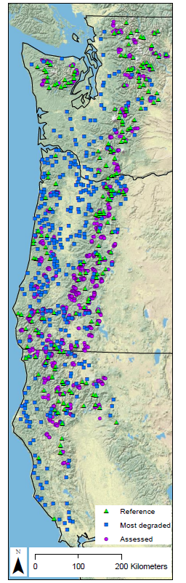
Figure 1. Reference, most degraded, and AREMP assessed site locations.

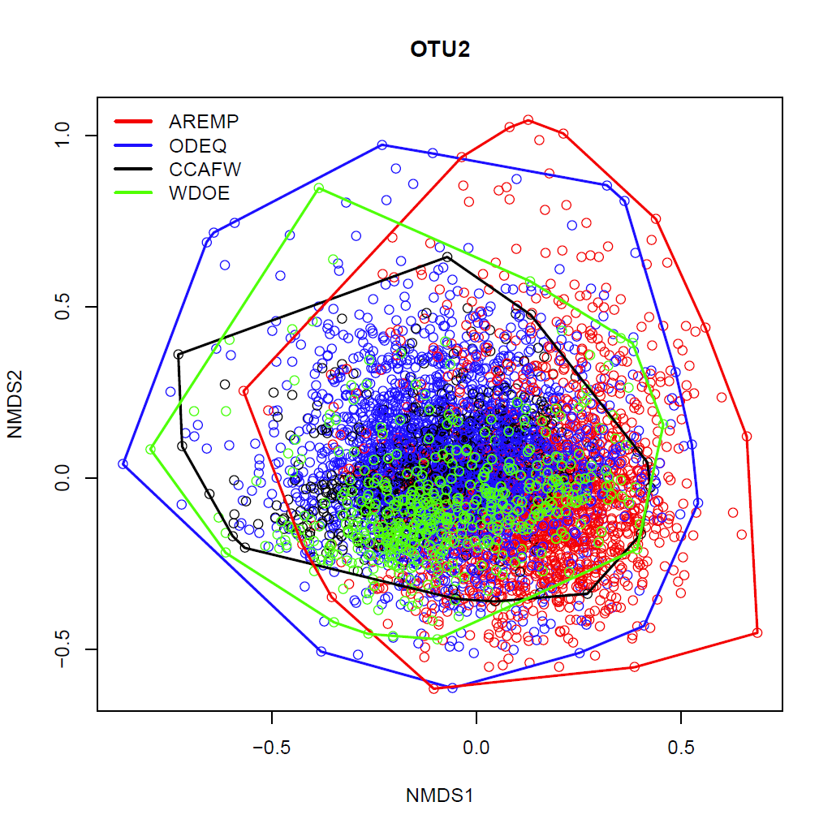

Metric | PC1 | PC2 | PC3 | PC4 | PC5 | PC6 | Axis Type
CLING_rich | 0.68 | 0.24 | 0.16 | -0.22 | -0.05 | 0.34 | Richness
INTOL_rich | 0.85 | 0.05 | 0.19 | 0.07 | 0.04 | -0.04 | Richness
EPT_rich | 0.91 | 0.17 | 0.17 | -0.02 | 0.03 | 0.11 | Richness
SCRAPER_rich | 0.42 | 0.32 | 0.14 | -0.35 | 0.09 | 0.27 | Richness
PLEC_rich | 0.67 | 0.03 | 0.06 | 0.32 | -0.05 | -0.16 | Richness
INSECT_rich | 0.81 | 0.03 | 0.43 | -0.10 | 0.03 | 0.21 | Richness
RICH | 0.78 | 0.00 | 0.44 | -0.13 | 0.18 | 0.20 | Richness
TRICHOP_rich | 0.51 | 0.10 | 0.22 | -0.01 | 0.12 | 0.43 | Richness
LLT_rich | 0.27 | 0.11 | 0.14 | 0.10 | -0.10 | 0.17 | Richness
EPHEM_rich | 0.55 | 0.24 | 0.01 | -0.37 | 0.01 | -0.17 | Richness
SHREDDER_rich | 0.55 | -0.13 | 0.04 | 0.40 | 0.03 | 0.00 | Richness
COLLGATH_rich | 0.43 | -0.07 | 0.26 | -0.37 | 0.11 | 0.19 | Richness
PER_EPT | 0.12 | 0.80 | -0.11 | 0.14 | -0.46 | -0.09
PER_DIPT | -0.16 | -0.92 | 0.05 | -0.17 | 0.07 | 0.05
PER_CHIRONOMID | -0.13 | -0.83 | 0.10 | -0.21 | 0.12 | -0.15
HBI | -0.14 | -0.70 | -0.20 | -0.46 | -0.33 | -0.07
PER_EPHEM | 0.07 | 0.50 | -0.30 | -0.49 | -0.28 | -0.31
PER_SCRAPER | 0.01 | 0.64 | 0.05 | -0.27 | 0.10 | 0.15
SHDIVER | 0.56 | 0.09 | 0.68 | 0.08 | 0.00 | 0.04
DIPT_rich | 0.09 | -0.33 | 0.57 | -0.21 | 0.08 | 0.25
CHIRONOMID_rich | 0.05 | -0.33 | 0.55 | -0.06 | 0.20 | 0.12
PER_PRED | 0.14 | -0.03 | 0.65 | 0.26 | 0.08 | -0.14
SIDIVER | 0.37 | 0.15 | 0.73 | 0.12 | 0.01 | 0.06
PRED_rich | 0.36 | -0.12 | 0.59 | 0.05 | 0.22 | 0.04
EVEN | 0.35 | 0.15 | 0.74 | 0.16 | -0.02 | 0.04
PER_INTOL | 0.18 | 0.39 | 0.43 | 0.44 | -0.15 | -0.11
PER_COLLGATH | -0.01 | -0.27 | -0.34 | -0.58 | -0.13 | -0.41
PER_PLEC | 0.06 | 0.12 | 0.14 | 0.83 | -0.09 | 0.01
PER_SHREDDER | -0.04 | 0.13 | 0.05 | 0.81 | -0.02 | 0.09
NON_INSECT_rich | 0.12 | -0.09 | 0.23 | -0.05 | 0.67 | -0.03
PER_NON_INSECT | 0.02 | -0.05 | 0.00 | 0.01 | 0.96 | 0.02
PER_INSECT | -0.02 | 0.05 | 0.00 | -0.01 | -0.96 | -0.02
PER_TOL | 0.05 | 0.01 | 0.04 | 0.03 | 0.16 | 0.46
TOL_rich | 0.10 | 0.04 | 0.03 | -0.15 | 0.03 | 0.62
PER_TRICHOP | -0.03 | 0.24 | 0.34 | 0.13 | -0.08 | 0.55
COLLFILT_rich | 0.22 | -0.03 | -0.15 | 0.15 | -0.26 | 0.45
PER_COLLFILT | -0.01 | -0.30 | -0.13 | 0.20 | -0.27 | 0.57
Table 2. PCA of adjusted, reference site metrics. Greyed boxes indicate metrics sharing axes. See Table 1 for metric abbreviation definitions.

Metric | Predictors | RF % var
Clinger richness | KFCT_WS, TMAX_WS, PMIN_WS, ELVmin_WS, rh_WS | 35.1
Dipteran richness | TMEAN_PT, TMEAN_WS, ELVmean_WS, ELVmin_WS | 19.1
LLT richness | TMEAN_WS, PMIN_PT, TMAX_WS, KFCT_WS | 63.9
Table 3. Model summaries for adjusted metrics in the final MMI. Predictors are listed left to right in order of importance. RF % var = percent of variation explained by natural gradients in the RF model.

 | Precision | Bias | Responsiveness |  | Sensitivity
Index | Ref site CV | RF % var | Mdeg t | Test t | Mdeg % IAD | Test % IAD
O/E | 0.14 | 0.00 | 9.69 | 9.00 | 31 | 25
MMI | 0.15 | 0.60 | 11.47 | 3.19 | 44 | 11
Table 4. Index performance measures. IAD = inferred as degraded.

