For all data in the database:
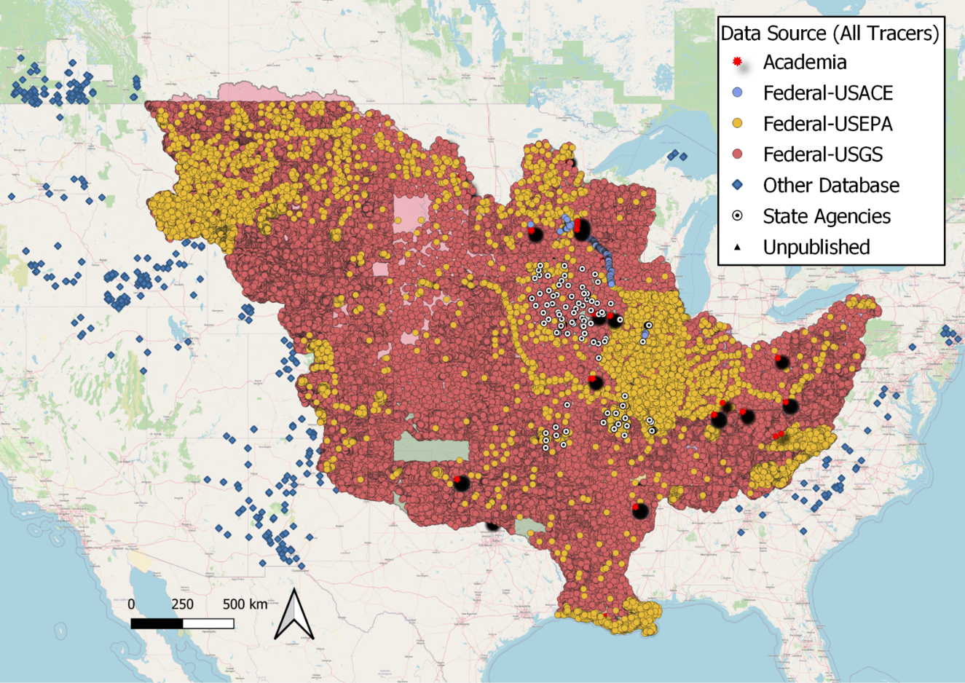
Figure 1. All sediment fingerprinting data included in the database.

The database currently includes 3,715,811 geochemical measurements from 225,035 sediment samples collected during 1969-2021.
Year | n | Percent
1969-1979 | 140,660 | 62.5
1980-1999 | 12,301 | 5.5
2000-2021 | 72,074 | 32.0

Across the whole collection period of 1969-2021, most samples were collected and analyzed by U.S. federal agencies.
Data Source | n | Percent
Academia | 5,249 | 2.33
Federal-USACE | 903 | 0.40
Federal-USEPA | 20,120 | 8.94
Federal-USGS | 195,335 | 86.80
Other Database | 1,356 | 0.60
State Agencies | 1,890 | 0.84
Unpublished | 182 | 0.08

There is an increasing trend in the contribution of fingerprinting data from academic institutions, which is consistent with the fact that more and more fingerprinting studies were conducted after 2000 for the Mississippi River Basin.
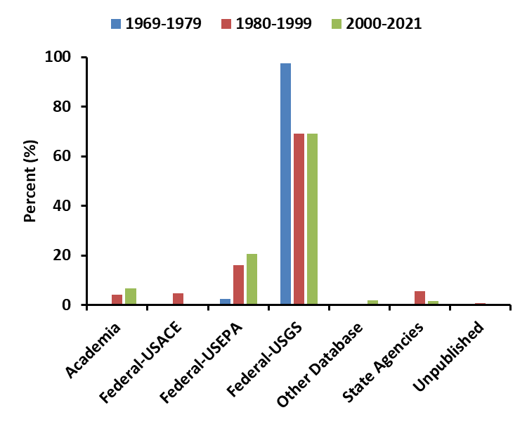
Figure 2. Percentages of sediment samples from various sources across 1969-2021.

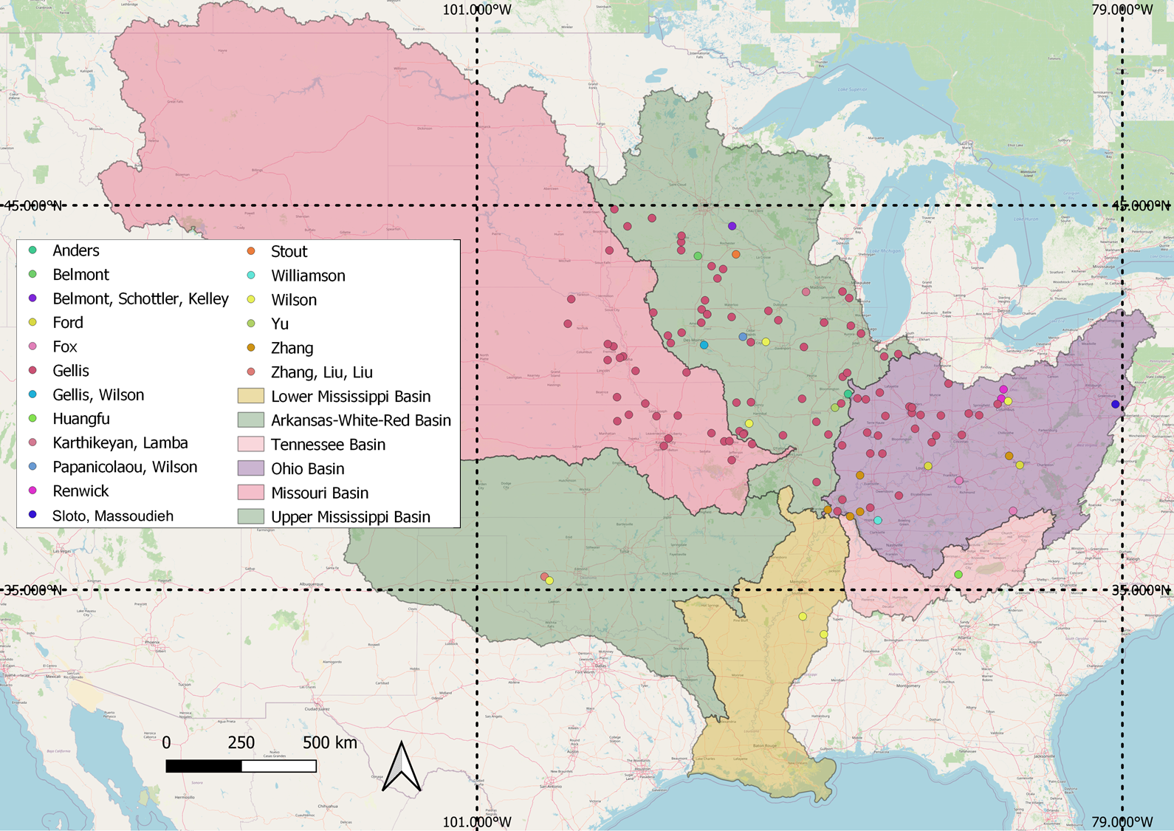
Figure 3 Established sediment source fingerprinting studies conducted within the Mississippi River Basin (n=46). Circles in different colors represent watersheds of interest in different publications. Last names of the corresponding authors are indicated next to circles. For a watershed investigated by multiple studies, last names of the corresponding authors from all studies are listed. All studies were published in or after 2000.

In terms of sediments from different landforms or land uses, most samples included in the database are considered as those from channel sources (e.g., fluvial erosion and channel storage).
Sample Type | Percent
Channel | 83.78
Upland | 13.78
Lake Sediment Core | 0.78
Suspended Sediment | 0.46
Other | 1.17
Unknown | 0.02

The dominant size range for samples included in the database is <150 µm, which is followed by the most used range in academic research (<63 or < 62.5 µm).
Size (µm) | n | Percent
<150 | 178539 | 79.3
<63 | 7740 | 3.4
<62.5 | 5159 | 2.3
125-500 | 2433 | 1.1
<2000 | 1530 | 0.7
Other | 2781 | 1.2
Missing | 26853 | 11.9

For samples with radionuclide tracer data:
As for samples with radionuclide tracer data, there is generally a lack of samples collected from headwaters of the Missouri, Ohio, Tennessee, and Arkansas-White-Red River basins as well as the Lower Mississippi River basin.
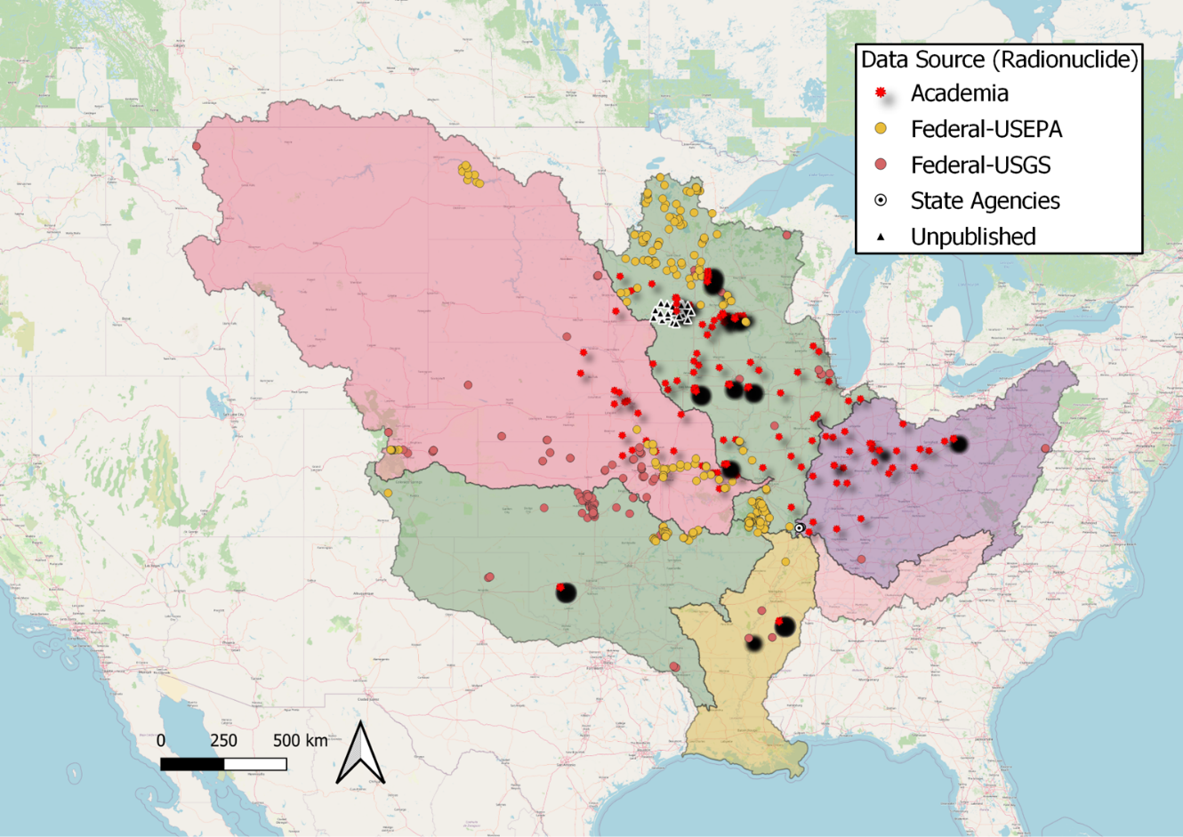
Figure 4. Sediment samples included in the database with radionuclide tracer data.

Most of included samples with radionuclide tracer data were collected in the past two decades.
Year | n | Percent
1980-1999 | 378 | 20.11
2000-2021 | 1,502 | 79.89

And a significant amount of data is from academia.
Data Source | n | Percent
Academia | 1,105 | 58.78
Federal-USEPA | 285 | 15.16
Federal-USGS | 159 | 8.46
State Agencies | 233 | 12.39
Unpublished | 98 | 5.21

This could be partially due to the increasing number of fingerprinting investigations in the academia in the past two decades as fallout radionuclide tracers are often considered robust to discriminate channel versus upland sources.
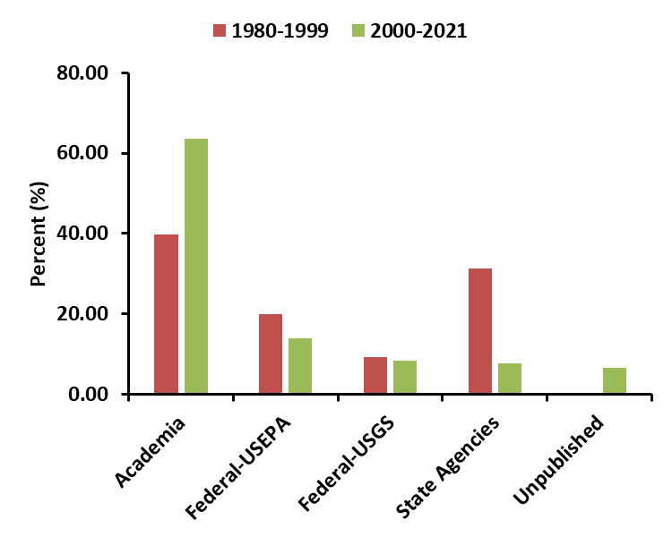
Figure 5. Percentages of sediment samples with radionuclide tracer data from various sources across 1980-2021.
A large portion of samples in this category is suspended sediment/lake sediment cores, which are often the target samples for fingerprinting studies.
Sample Type | Percent
Channel | 33.30
Upland | 19.20
Lake Sediment Core | 20.53
Suspended Sediment | 26.17
Other | 0.80

The size range of <63 µm is much more popular for this category.
Size (µm) | n | Percent
<125 | 27 | 1.4
<2 | 48 | 2.6
<53 | 52 | 2.8
<62 | 24 | 1.3
<62500 | 80 | 4.3
<63 | 458 | 24.4
Missing | 1191 | 63.4

It is worth noting that federal agencies only contribute 23.62% samples for radionuclide tracer data, which is probably due to the fact that radionuclide data analysis is often not included in the routine environmental monitoring program as a result of high analytical expenses and limited number of laboratories to do the analysis.

For samples with inorganic tracer data:
Most samples included in the database provide inorganic tracer data, as many of them were from various federal environmental monitoring programs. These monitoring programs often conducted ICP-OES (Inductively coupled plasma - optical emission spectrometry) or ICP-MS (Inductively coupled plasma mass spectrometry) analysis for results of more than 30 elements at a time.

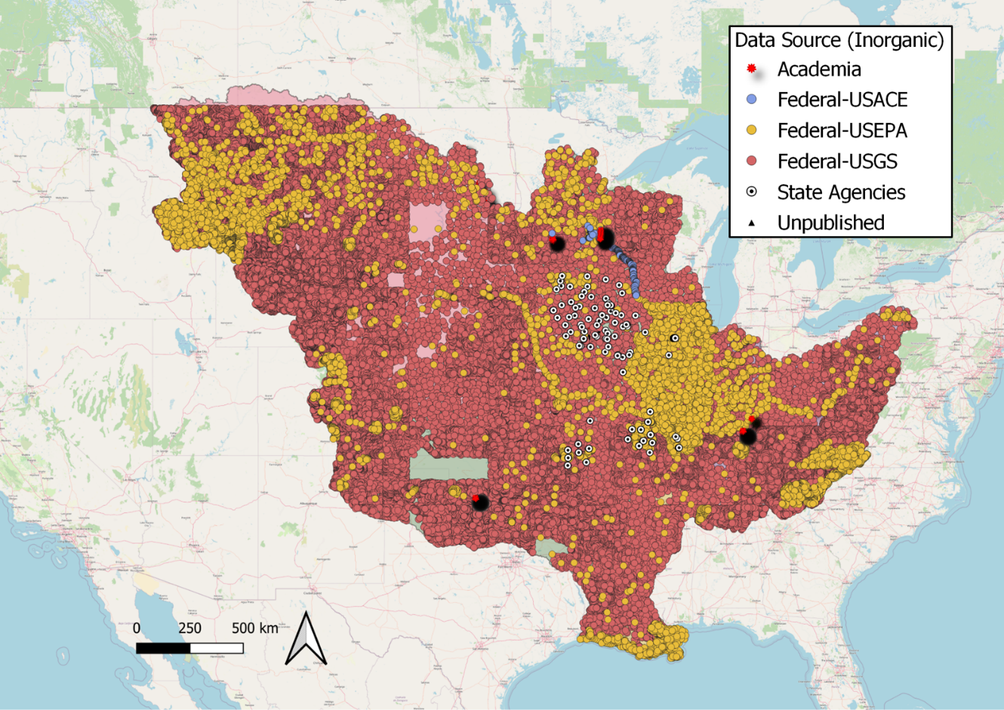
Figure 6. Sediment samples included in the database with inorganic tracer data.

Less samples were collected and analyzed during 1980-1999 for inorganic tracer data.
Year | n | Percent
1969-1979 | 140,659 | 64.86
1980-1999 | 11,633 | 5.36
2000-2021 | 64,569 | 29.77

As mentioned above, U.S. federal agencies are dominant contributors for inorganic fingerprinting data.
Data Source | n | Percent
Academia | 1,738 | 0.80
Federal-USACE | 814 | 0.38
Federal-USEPA | 18,432 | 8.50
Federal-USGS | 194,345 | 89.62
State Agencies | 1,448 | 0.67
Unpublished | 84 | 0.04

This is even true for the period of 1980-1999.
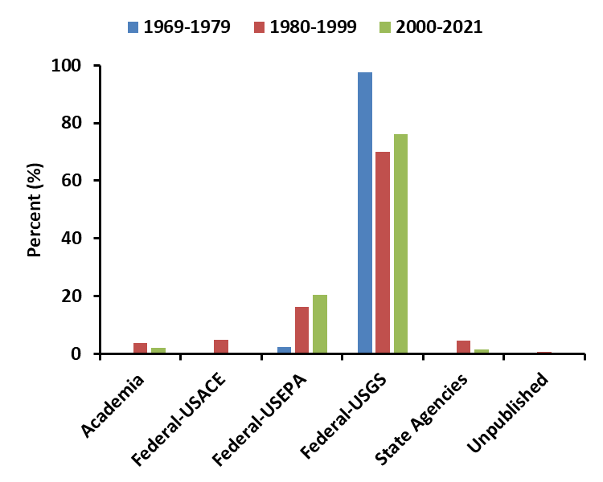
Figure 7. Percentages of sediment samples with inorganic tracer data from various sources across 1969-2021.

Most samples in this category are considered as those from channel sources.
Sample Type | Percent
Channel | 84.57
Upland | 14.02
Lake Sediment Core | 0.59
Suspended Sediment | 0.21
Other | 0.59
Unknown | 0.02

And most of them are sieved to <150 µm before analysis.
Size (µm) | n | Percent
<150 | 178539 | 82.3
<63 | 6723 | 3.1
<62.5 | 4976 | 2.3
<2000 | 1215 | 0.6
<149 | 546 | 0.3
Other | 1814 | 0.8
Missing | 23048 | 10.6

For samples with isotope tracer data:
Most samples with isotope tracer data are collected by research groups in academic institutions. Many of them are only available along the Mississippi River main channel.
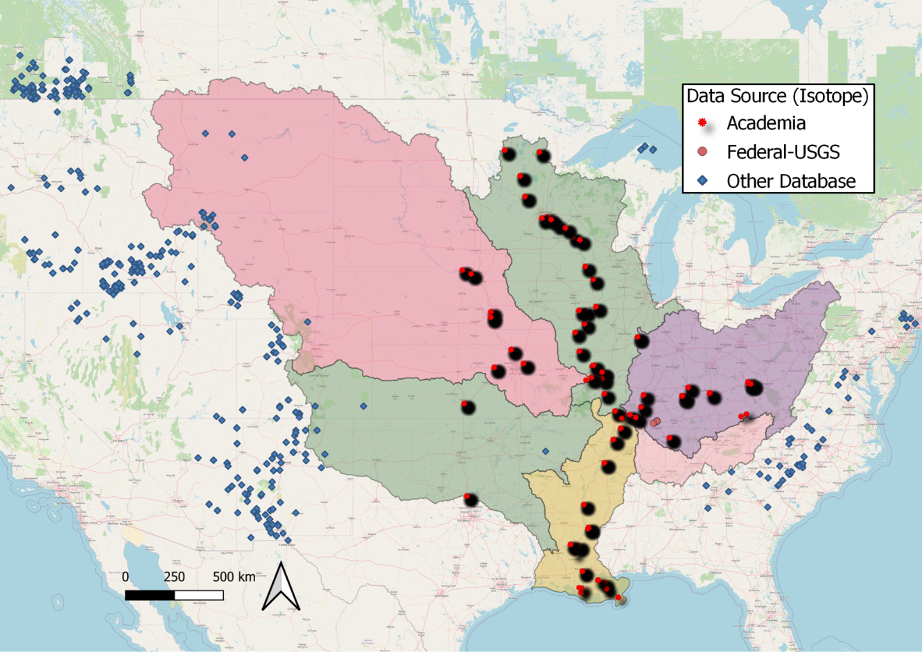
Figure 8. Sediment samples included in the database with isotope tracer data.

Most included data are from samples collected after 2000.
Year | n | Percent
1980-1999 | 16 | 0.37
2000-2021 | 4256 | 99.63

Except for data from peer-reviewed publications, a large portion of data is from publicly accessible geologic databases.
Data Source | n | Percent
Academia | 2898 | 67.84
Federal-USGS | 18 | 0.42
Other Database | 1356 | 31.74

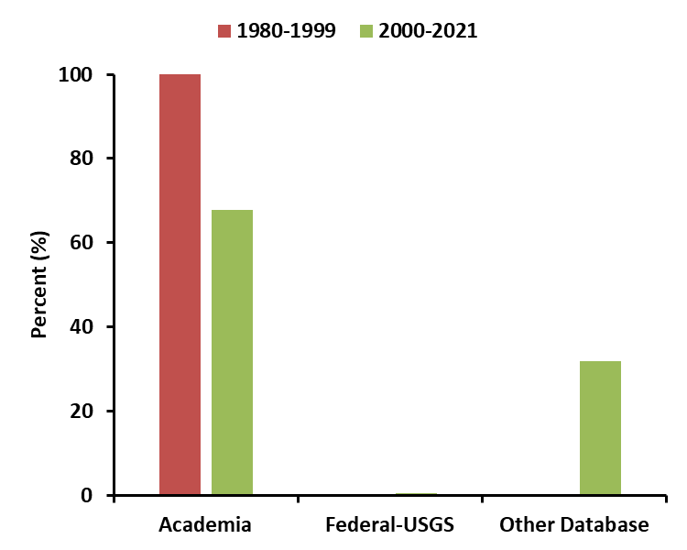
Figure 9. Percentages of sediment samples with isotope tracer data from various sources across 1980-2021.

A considerable portion of data is for upland samples.
Sample Type | Percent
Channel | 57.77
Upland | 34.85
Lake Sediment Core | 2.39
Suspended Sediment | 4.99

The dominant size range for this category is 125-500 µm.
Size (µm) | n | Percent
125-500 | 2433 | 57.0
<53 | 161 | 3.8
<62.5 | 113 | 2.6
<63 | 100 | 2.3
<0.7 | 38 | 0.9
<250 | 6 | 0.1
Missing | 1421 | 33.3

It is worth mentioning that all stable carbon and nitrogen isotope data (δ¹³C and δ¹⁵C) included in the category are bulk isotope data. There is a lack of compound specific stable isotope (CSSI) data for the Mississippi River basin.

For samples with organic tracer data:
Organic tracer data are relatively deficient in the Arkansas-White-Red basins.
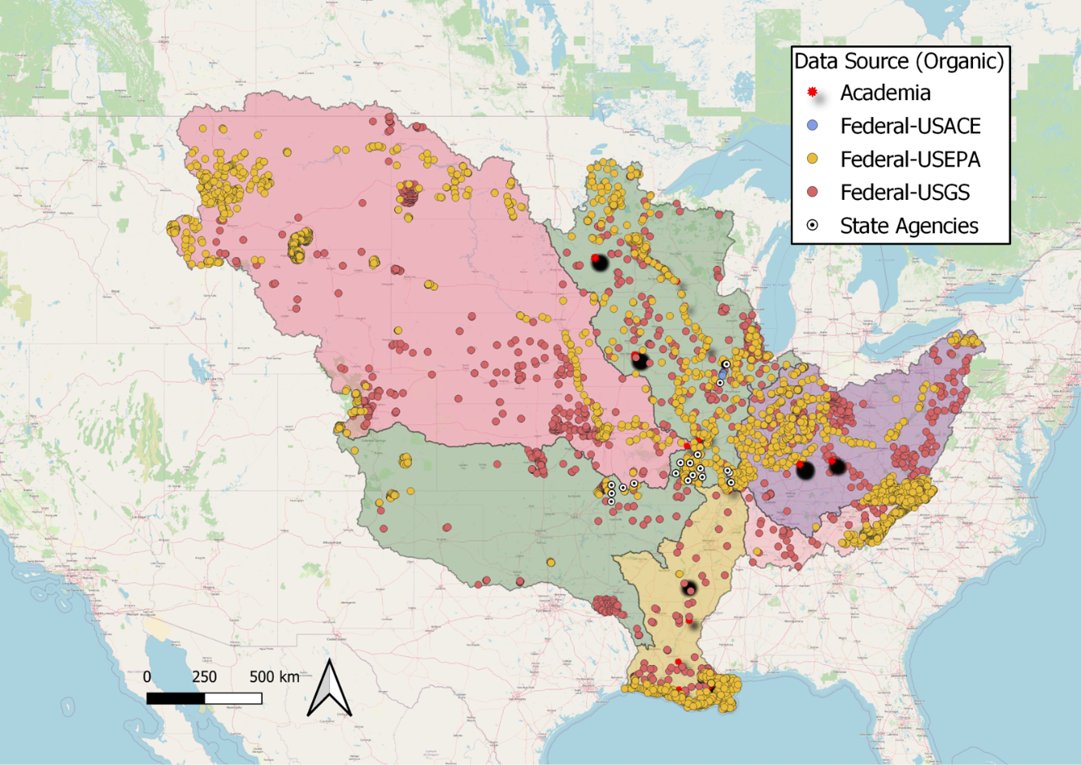
Figure 10. Sediment samples included in the database with organic tracer data.

Most samples for this category were collected after 2000.
Year | n | Percent
1969-1979 | 12 | 0.16
1980-1999 | 1810 | 24.82
2000-2021 | 5471 | 75.02

U.S. EPA is the dominant contributor for organic tracer data, especially for the past two decades.
Data Source | n | Percent
Academia | 391 | 5.36
Federal-USACE | 89 | 1.22
Federal-USEPA | 3933 | 53.93
Federal-USGS | 2498 | 34.25
State Agencies | 382 | 5.24

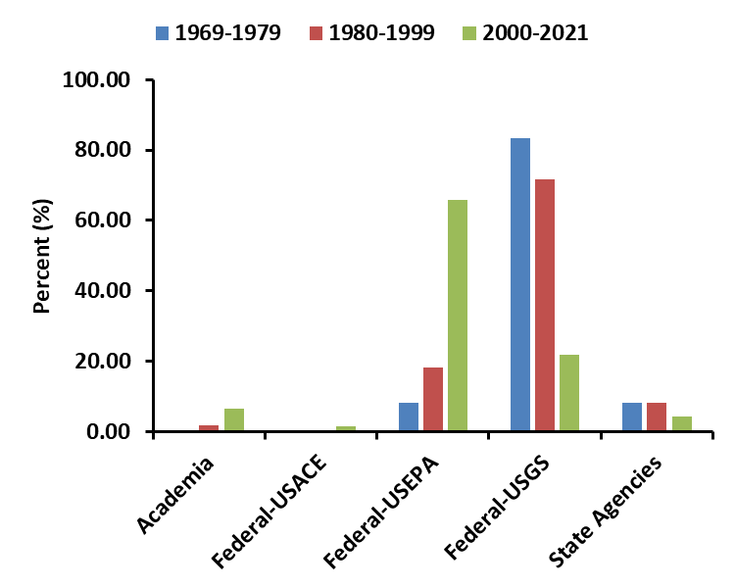
Figure 11. Percentages of sediment samples with organic tracer data from various sources across 1969-2021.

Most samples were collected from riverbed (33%) and areas near river channel (34%).
Sample Type | Percent
Channel | 84.52
Upland | 8.10
Lake Sediment Core | 3.44
Suspended Sediment | 3.17
Other | 0.77

Size fractionation was only conducted for 40.8% samples.
Size (µm) | n | Percent
<62.5 | 1021 | 14.0
<63 | 940 | 12.9
<2000 | 794 | 10.9
<149 | 148 | 2.0
<53 | 43 | 0.6
>1 | 27 | 0.4
<250 | 6 | 0.1
Missing | 4314 | 59.2

For samples with other types of tracer data:
This category includes total carbon, total nitrogen, and C/N ratio, which were used in some fingerprinting studies.
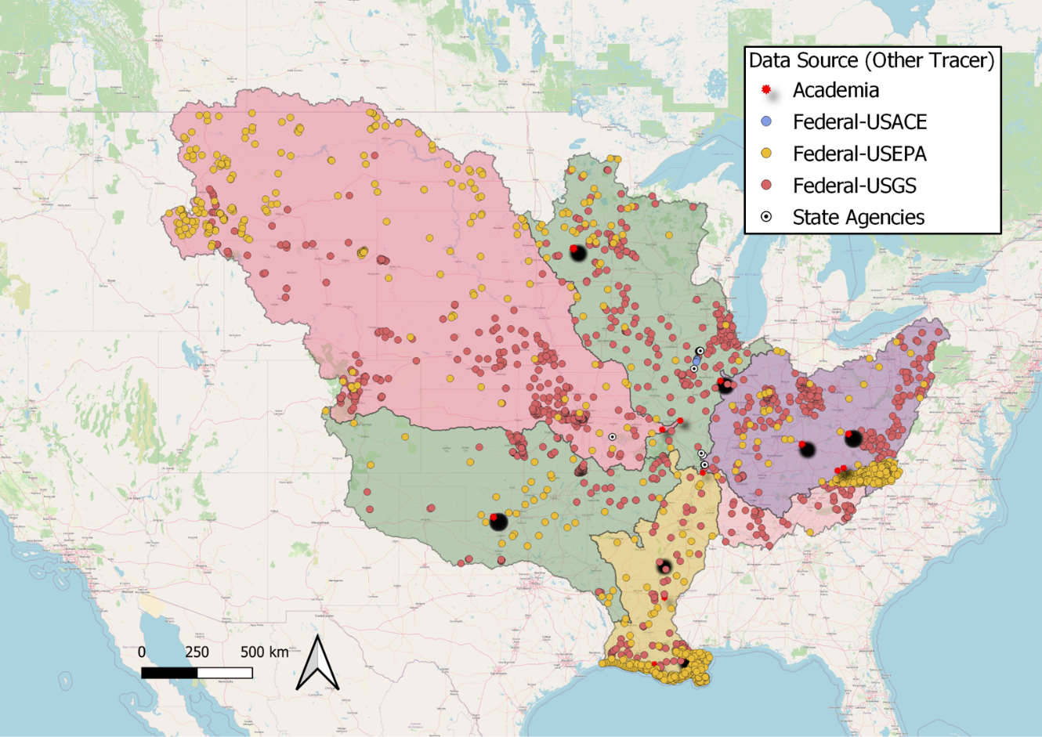
Figure 12. Sediment samples included in the database with other types of tracer data.

Most of these data were collected in the past two years.
Year | n | Percent
1969-1979 | 3 | 0.0807972
1980-1999 | 1381 | 37.193644
2000-2021 | 2329 | 62.7255588

Federal agencies are the main data contributors.
Data Source | n | Percent
Academia | 617 | 16.62
Federal-USACE | 89 | 2.40
Federal-USEPA | 889 | 23.94
Federal-USGS | 1943 | 52.33
State Agencies | 175 | 4.71

Figure 13. Percentages of sediment samples with isotope tracer data from various sources across 1969-2021.

Most samples were collected along the rivers.
Sample Type | Percent
Channel | 76.22
Upland | 6.71
Lake Sediment Core | 8.81
Suspended Sediment | 8.27

The size range of <62.5 and <63 µm is the most commonly used size fractionation.
Size (µm) | n | Percent
<62.5 | 906 | 24.4
<2000 | 532 | 14.3
<63 | 389 | 10.5
<53 | 161 | 4.3
<149 | 148 | 4.0
<250 | 6 | 0.2
Missing | 1571 | 42.3

There are other types of tracers used for fingerprinting, such as magnetism, spectrocolorimetrics (color), and mineralogy. However, at current stage we found that such data are generally deficient for the Mississippi River basin.

